Creating Azure Web App and Register the custom domain

1. Sign Up for Free Azure Subscription using the student dev pack.

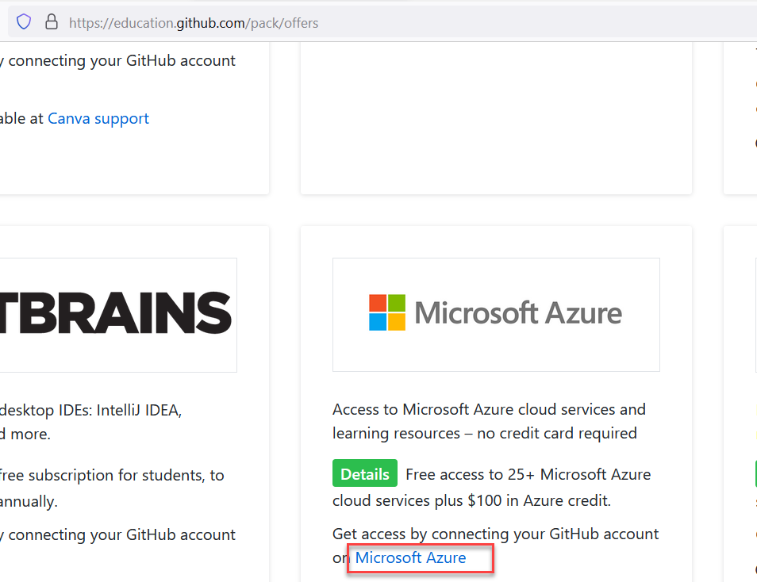

1. Once on Microsoft Azure Website, use “Start Free”

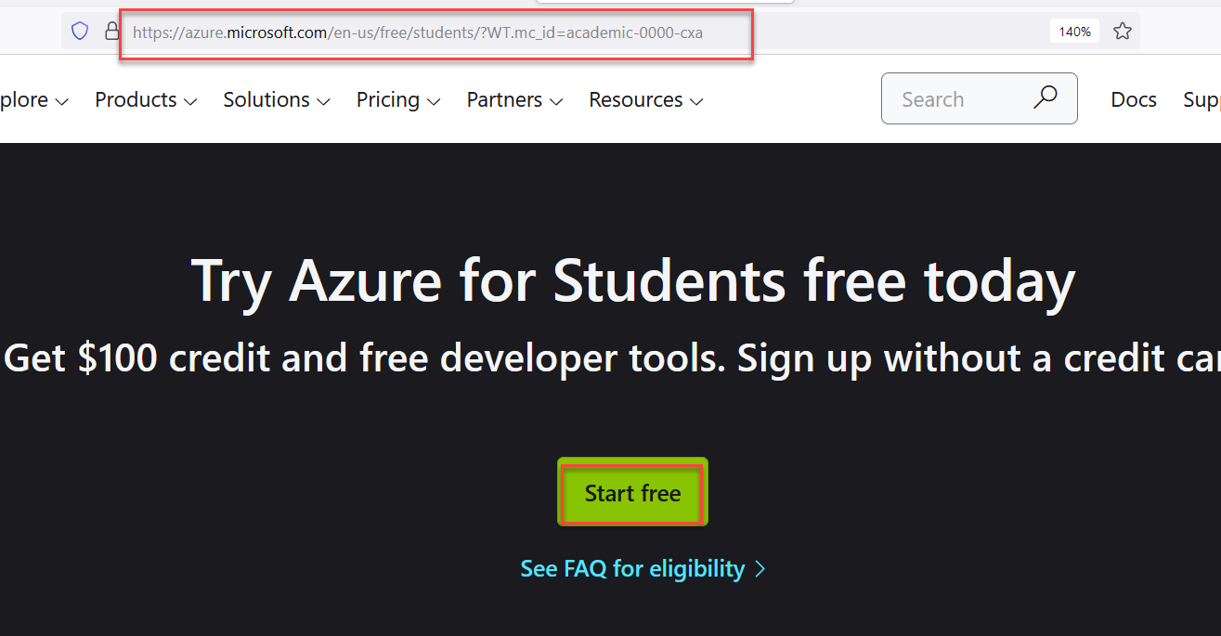

1. Use “GitHub” Account linked with student-dev-pack to signup for azure subscription.

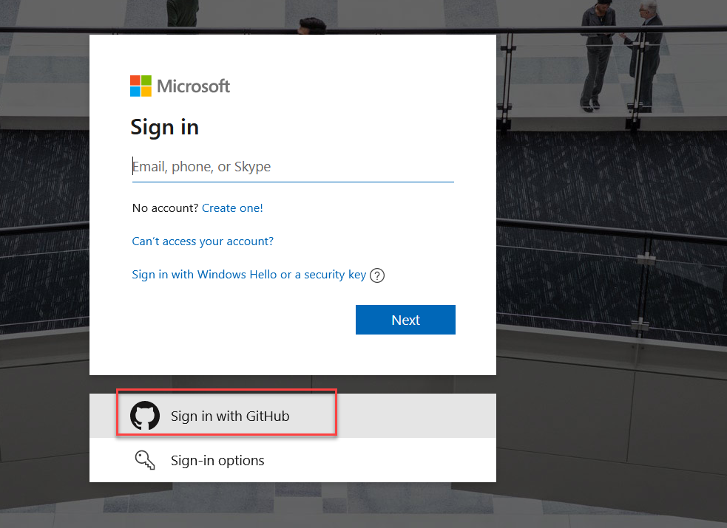

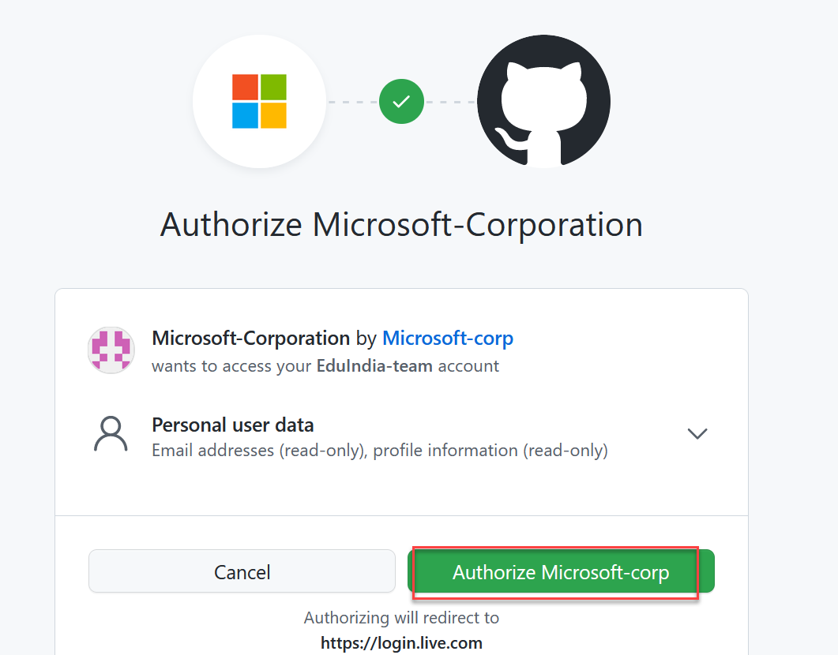

1. Just follow on screen instructions and fill up all required details to activate your free azure account.
2. Once azure subscription is activated, login to <https://portal.azure.com>
3. You need to create new azure app service

Choose Runtime stack as php 7.3 (Our application is just plain html+js+css though)

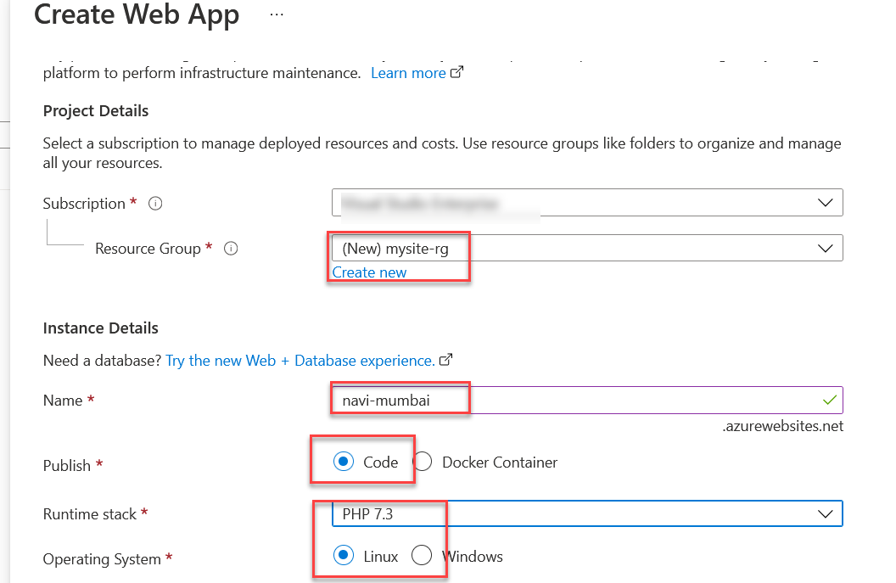

1. Choose region “Southeast Asia” (or try some other if it fails you need start all over again)

And then change the “size”

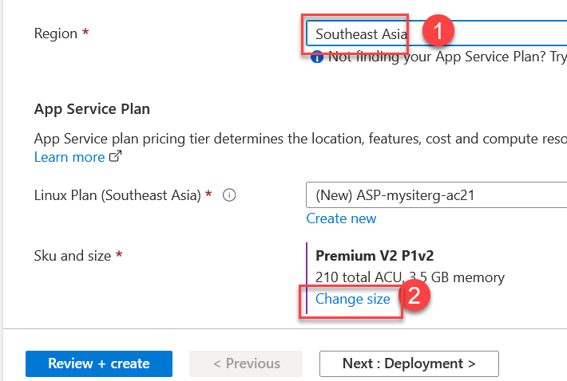

1. You need to select Basic B1

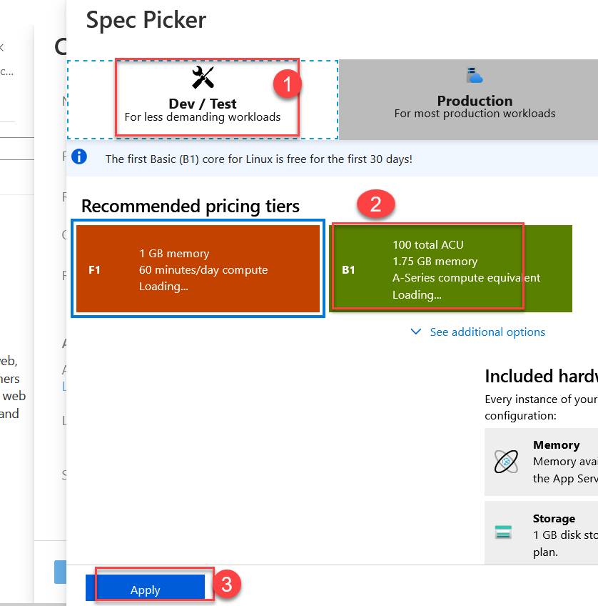

1. Now, click “Review + Create” to start the provisioning

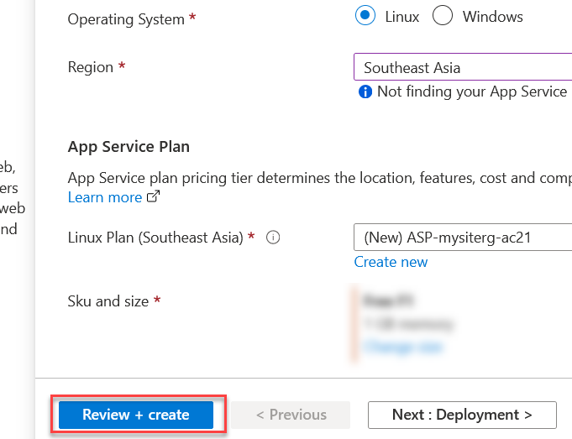

1. Once your application is ready, just click on “Go to Resource” to get details of your new azure app service.

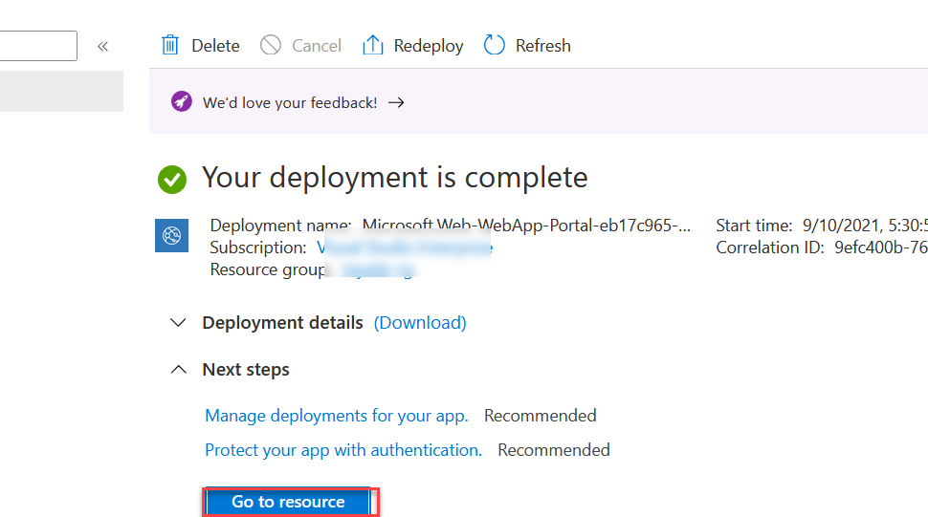

1. Once App Service details are presented on your screen locate “Custom Domain” and then click on “Add Custom Domain” link

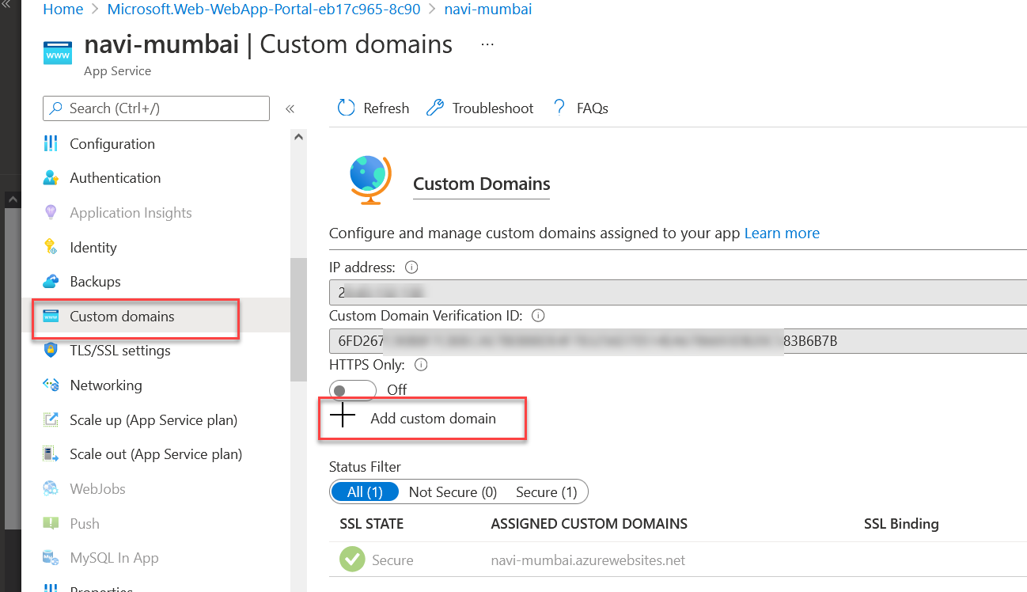

1. Now, you need to enter the domain you have recently purchased from namecheap.com

And click validate button.

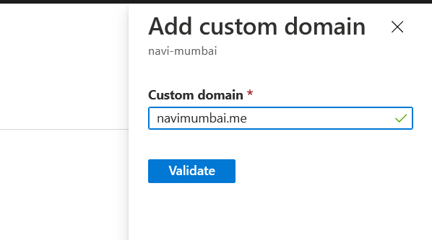

1. Choose hostname record type as “A Record” from drop down (in same box, just below “Validate” button)

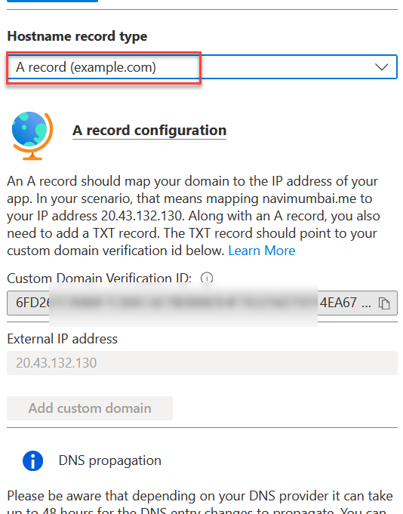

1. Now, Please copy the two highlighted values for the DNS Ownership Validation.

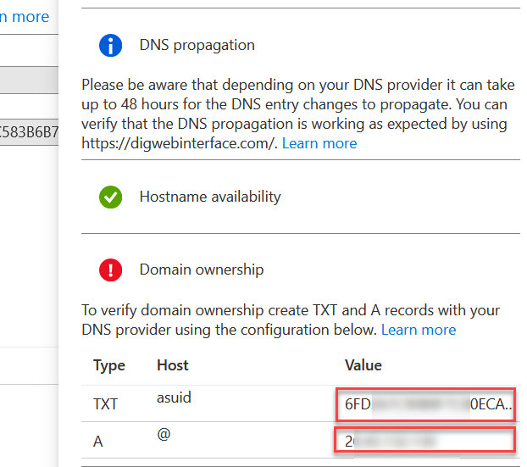

NOTE: Copy the entire ROW “TXT asuid XXXXXXXXXXXXXXXXX” and “A @ XX.XX.XX.XX”

You need these values in step-20.

1. You cannot use the domain name yet as the “Domain Ownership” has failed. But don’t worry, we would revisit this option in step# 22.
2. Now Open a new browser tab / window and login into <https://namecheap.com> with your new credentials (refer to demo1).

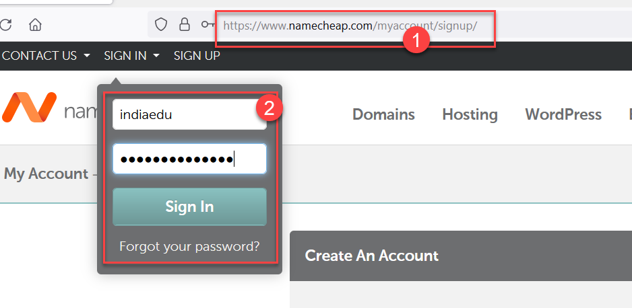

1. Now, There should be option to “Manage” your domains.

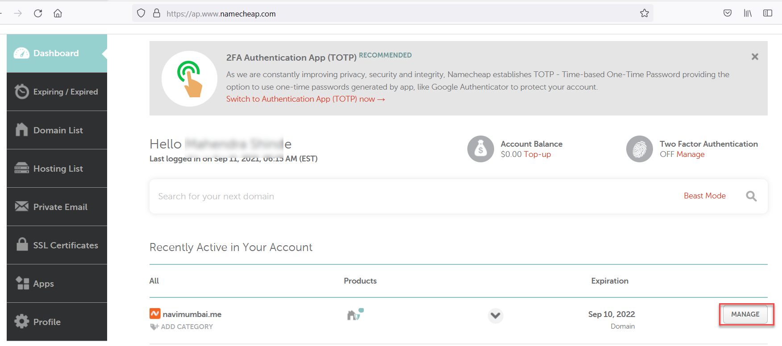

1. On Next Screen, just click on “Advanced DNS” to get DNS Options.

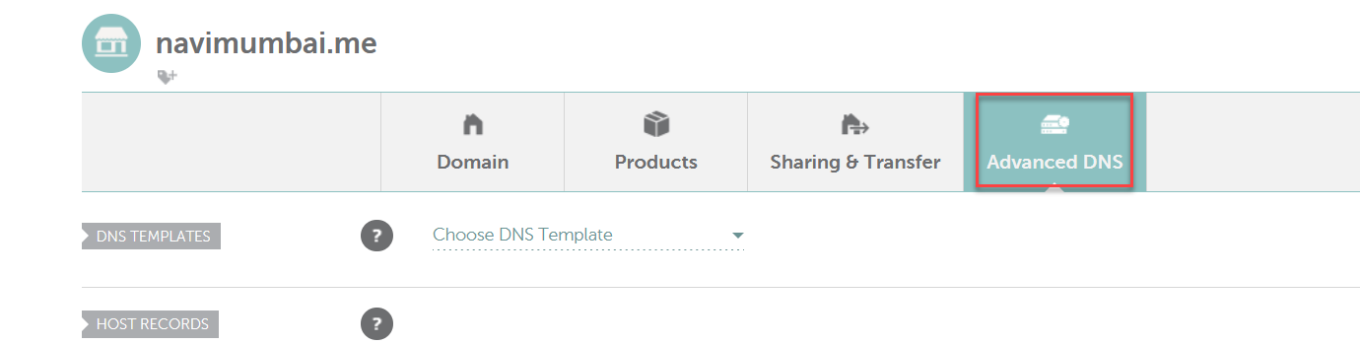

1. And delete all the existing Mapping highlighted in RED boxes. (If you don’t get anything to delete that’s all fine !). After you delete all entries, proceed with “ADD NEW RECORD”

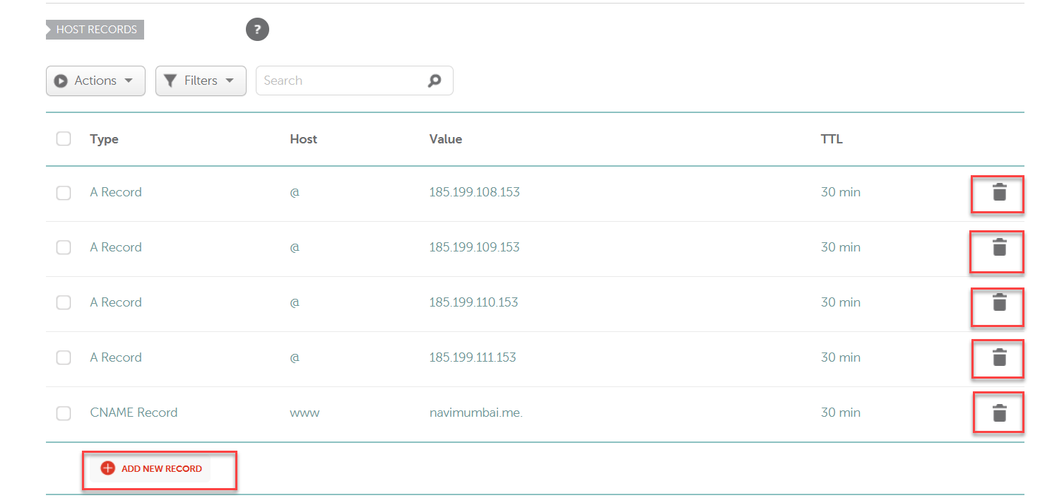

1. Now, Its time to use values you copied (A record and TXT record) from step# 14

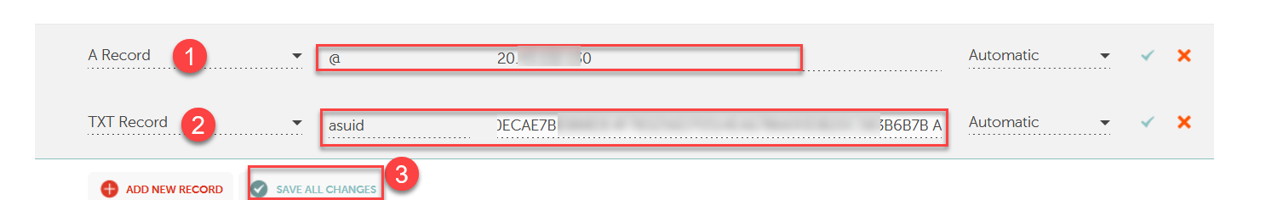

1. After you add both values, please click “Save All Changes” button.
2. Now, it time to go back at step #15 (A Browser window I intentionally left open).

You need to Click the Validate button once again and should get “Ownership Verification Succeeded” this time.

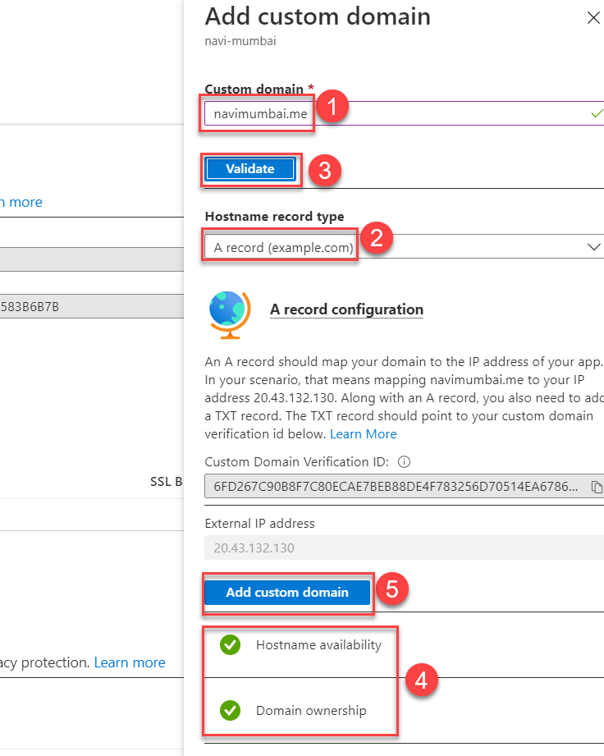

Just Hit “Add Custom domain” button after verification ends.

1. Congrats! Now your azure app service is linked with a new custom domain !!